Cov Tsev Kawm Spring Lake Park Npau Ntawv Qhia Rau Niam Txiv txog Schoology
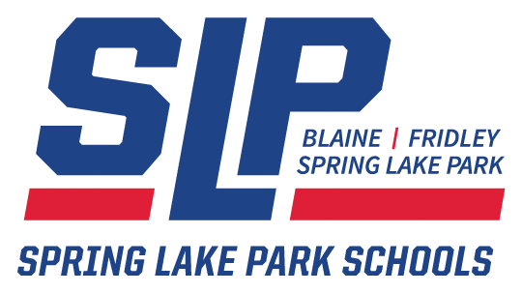

Zoo Siab Txais Tos Tuaj rau Schoology! Phau ntawv qhia no yuav pab cov niam txiv thiab cov neeg saib xyuas kom kag siab txog tias Schoology yog dab tsi thiab yuav siv nws tau li cas. Koj tuaj yuav nriav kev paub ntau ntxiv ntawm tus vev xaib ntawm Chaw Pab Cuam Schoology ntawm support.schoology.com
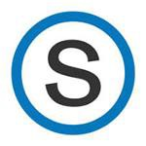

Schoology Yog Dab Tsi?

Schoology yog ib Txoj Hauj Lwm Tswj Hwm Kev Kawm hauv online uas pab kom koj paub txog koj tus me nyuam cov kev kawm hauv chav, cov luag hauj lwm thiab cov qhab nias kawm. Koj tuaj yeem siv Schoology los:
● Txheeb xyuas koj tus me nyuam cov fab kev kawm thiab cov pab pawg kawm
● Txheeb xyuas koj tus me nyuam cov luag hauj lwm, cov qhab nias kawm thiab cov kev muab los pom zoo yav tom ntej, tam sim no thiab yav dhau los
● Soj ntsuam cov kev tshaj qhia ntawm tsev kawm thia fab kev kawm

Txoj Hauv Kev Nkag Mus rau Txoj Hauj Schoology

● Mus rau https://schoology.springlakeparkschools.org
● Siv lub npe siv thiab tus zauv zais uas koj tau txais los ntawm Cov Tsev Kawm Spring Lake Park
● Yog koj tsis muaj lub npe siv thiab tus zauv zais, tiv tauj rau Feem Txhawb Pab Txheej Teg ntawm Spring Lake Park ntawm techsupport@district16.org

Kev Siv Koj Tus As Khauj Schoology Niam Txiv/Tus Saib Xyuas

Txheeb xyuas koj tus me nyuam cov dej num

Nias rau tus xub taw qhov kev siv nqis mus ntawm lub ces kaum sab saud ntawm sab xis ntawm koj tus as khauj uas nyob txuas ntawm koj lub npe. Xaiv koj tus me nyuam lub npe txhawm rau txheeb xyuas qhov dej num ntawm tus as khauj.

Nplooj Xub Thawj
Cov niam txiv thiab cov me nyam yuam muaj Nplooj Xub Thawj uas raug cais tawm. Zoo ib yam nkaus li hauv Facebook, Nplooj Xub Thawj yog thawj qhov chaw uas tus neeg siv pom tom qab thaum nkag mus tau rau Schoology. Nyob rau qhov no, koj yuav pom txhua cov xwm txheej, cov dej num los sis cov kev hloov kho tshiab
uas tau raug muab tso rau.

Cov Fab Kev Kawm
Nyob rau qhov no koj yuav pom txhua cov fab kev kawm ntawm koj tus me nyuam raug teev tseg rau nov..
Nias rau ib fab kev kawm txhawm rau saib ntaub ntawv, cov kev piav meej tsiab thiab cov luag hauj lwm ntau ntxiv.

Cov Pab Pawg Kawm
Cov pab pawg kawm raug siv tas li rau cov ntaub ntawv, cov dej num, los sis cov kev nyiam tshwj xeeb. Piv txwv li, tej zaum koj tus me nyuam yuav yog ib tug uas koom rau hauv pab pawg kis las uas nyob hauv Pab Pawg Schoology. Cov pab pawg yuav tsis teev cov qhab nias.

Nco Cim Tseg: Cov neeg saibx yuas tsuas tuaj yeem pom lawv cov me nyuam tus as khauj Schoology, Cov Fab Kev Kawm thiab Cov Pab Pawg xwb. Lawv tsis tuaj yeem koom tau rau Cov Fab Kev Kawm los sis Cov Pab Pawg, los sis tsis tuaj yeem nruab lus pom zoo, los sis saib lwm cov ntaub ntawv.

Kev Coj Kev ntawm Cov As Khauj Schoology Tub Ntxhais Kawm:
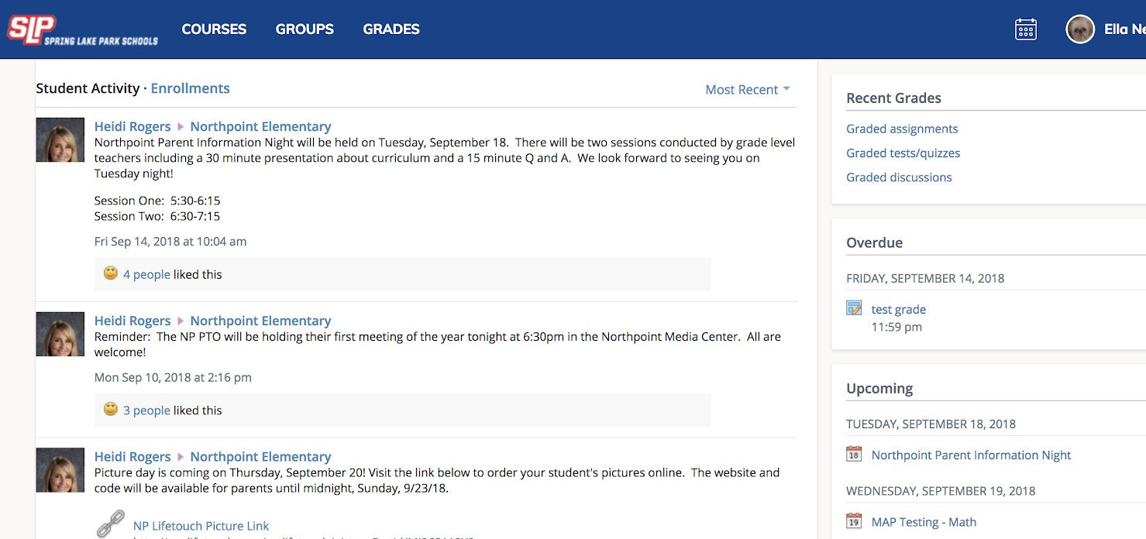

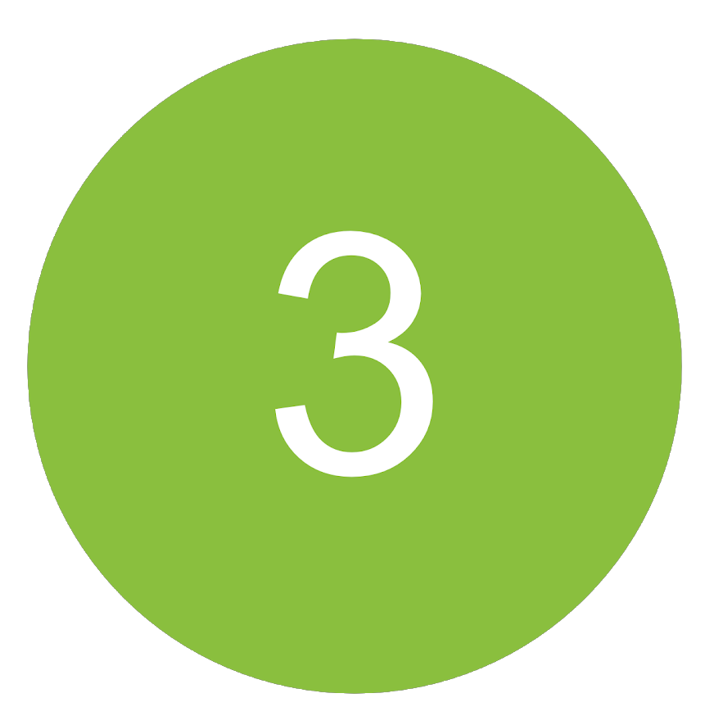

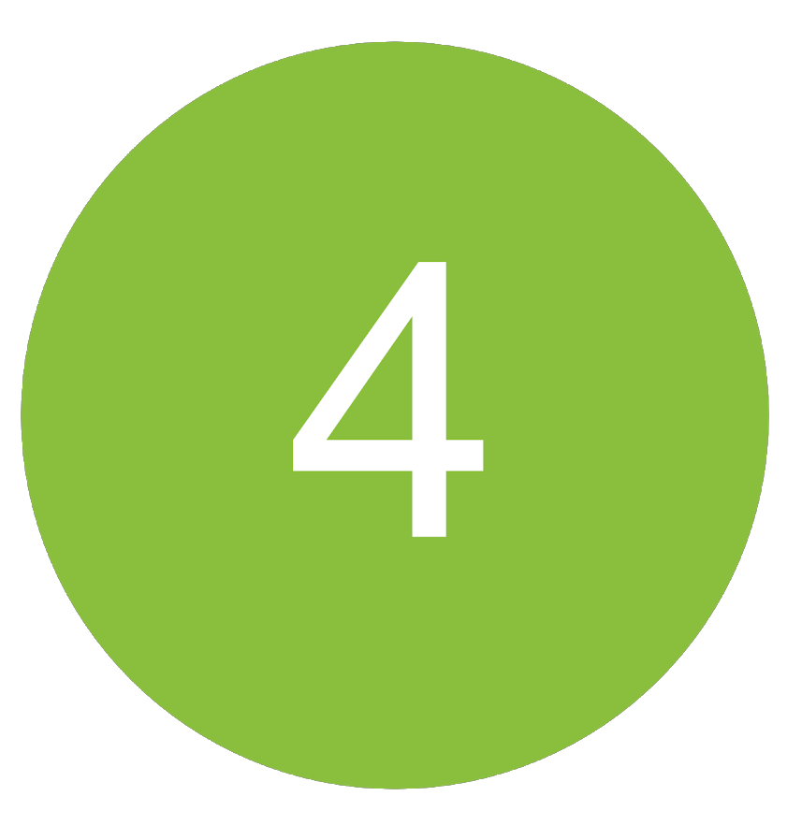

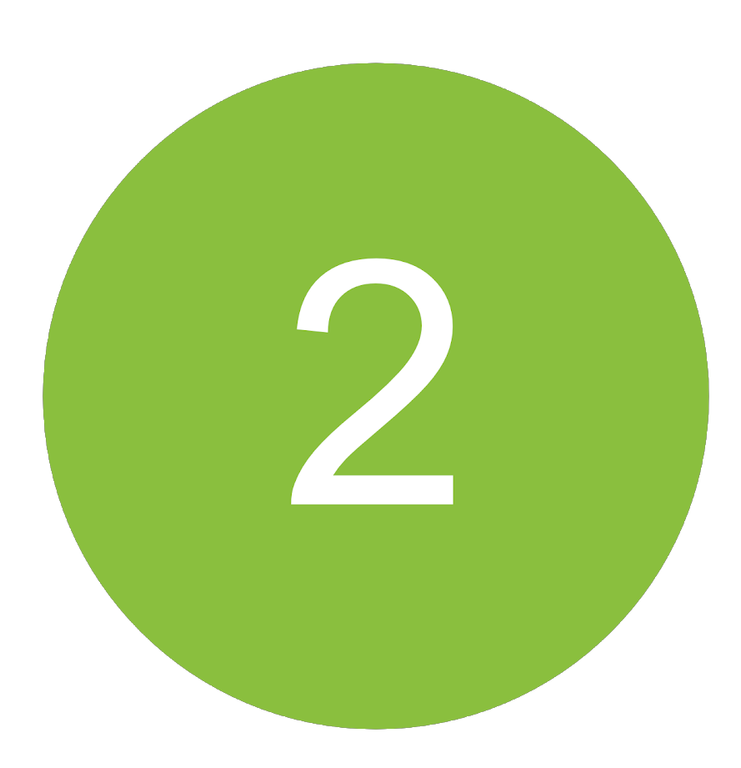

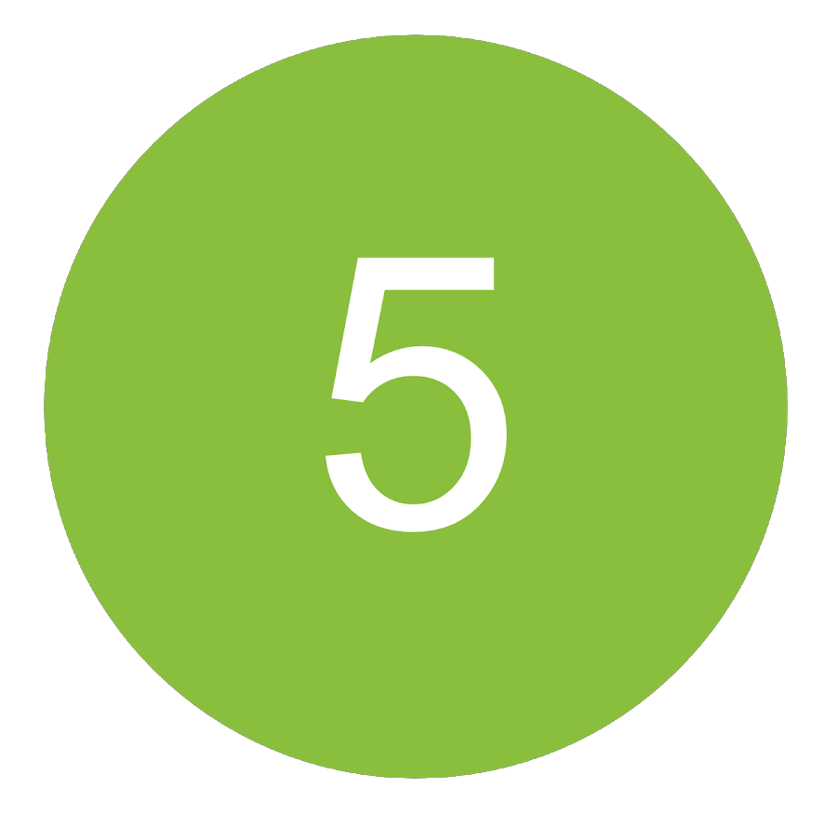

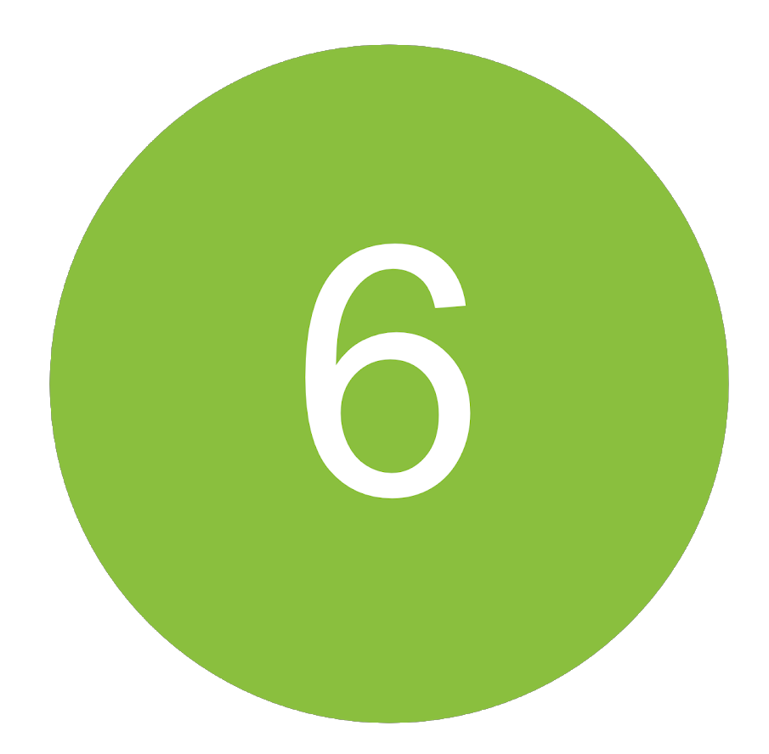

Thaum xaiv koj tus me nyuam lub npe ntawm lub ces kaum sab saud ntawm sab xis, koj tuaj yeem txheeb xyuas cov ntaub ntawv faj seeb kiag tam siv txog koj tus me nyuam cov dej num Schoology:
Nias rau Cov Kev Tso Npe txhawm rau saib qhov nthuav dav txog ntawm tus me nyuam cov fab kev kawm thiab cov qhab nias kawm, Nias rau Tub Ntxhais Kawm Li Dej Num txhawm rau saib cov kev tshaj qhia txog cov qhab nias kawm ua leej neej ntawm cov luag hauj lwm thiab cov kev hloov kho tshiab. Kev nias rau ntawm lub looj duab SLP ntawm lub ces kawm sab saud ntawm sab laug yuav ua rau koj rov qab los rau nplooj no.

Xaiv rau Cov Kev Tso Rau hauv kem nruab nrab txhawm rau saib qhov kev teev ntawm kev tus me nyuam cov fab kev kawm tam sim no, nrog rau lawv cov qhab nias tag nrho. Nias rau fab kev kawm ua leej neeg txhawm rau saib cov qhab nias rau cov luag hauj lwm, kev cov kuaj ntsuas, thiab cov kev sib tham.

Hauv qab ntawm Cov Pab Pawg, koj yuav pom qhov kev teev ntawm koj tus me nyuam Cov Pab Pawg Schoology. Cov pab pawg tuaj yeem siv tau rau ntau cov dej num, ntawm cov phiaj xwm hauv tsev kawm txhawm rau cov pab pawg thiab cov chaw ntawm fab kev kawm sab nraud.

Tshooj ntawm Cov Qhab Nias yuav qhia txog koj tus me nyuam tus qhab nias sau koom ua ke nyob rau tam sim no.

Tshooj ntawm Kev Tsis Tau Xa yuav qhia txog qhov kev teev ntawm cov khoom fab kev kawm uas koj tus me nyuam tsis tau xa tuaj raws lub sij hawm.

Tshooj ntawm Yav Tom Ntej yuav qhia txog qhov kev teev ntawm cov luag hauj lwm thiab cov xwm txheej yav tom ntej.
